The Battle of Neighborhoods

Applied Data Science Capstone Project

Alexandra Lohmeyer

# Introduction

* In this project we will help people who are looking for renting an apartment in Vienna. If they are looking to move to Vienna they can see:
  1. Which district has cheaper rent or,

○ They can choose to live in residential or commercial areas and can see for example which residential districts is best

* Or, if they already live in one of the 23 districts in Vienna they will be able to see:
  1. If they are paying more than the average price for their apartment

○ If there are similar districts to theirs with lower rents

* Data on apartments is collected by scraping a local website with apartment listings (willhaben.at)
  1. In total 8045 apartments with data like size, number of rooms, address, and price
* Using geopy coordinates for each district are obtained
* Foursquare data to collect top 10 venues for each district

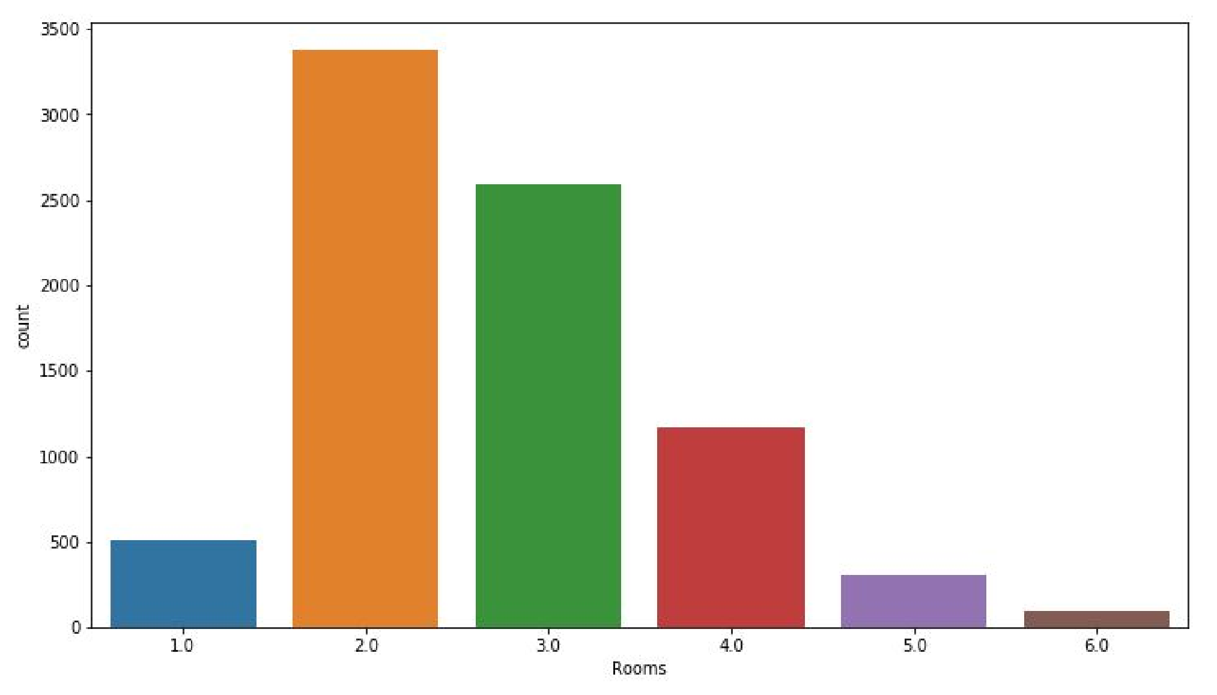

From this we can see that 2 and 3 room apartments are the most common.

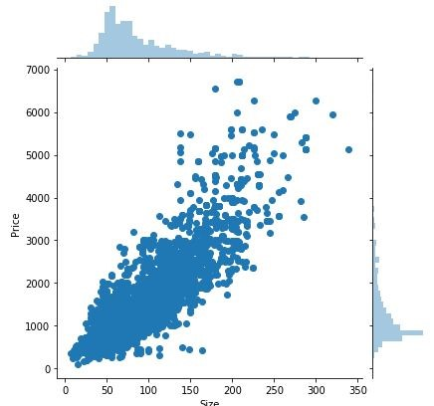

Correlation between the price and apartment size. As expected, the larger the apartment, the higher the monthly rent

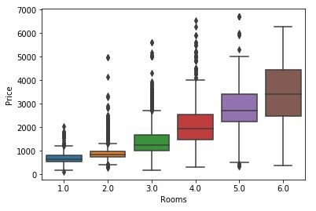

We expect the value of properties to go up as the number of rooms increases. The interesting aspect in this boxplot is that 1 and 2 room apartments are competing in the same price range.

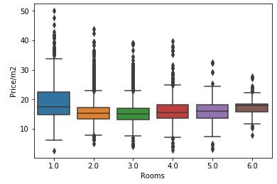

The price/m2 is in the same price range for all size apartments besides for single room apartments where the price/m2 goes even higher.

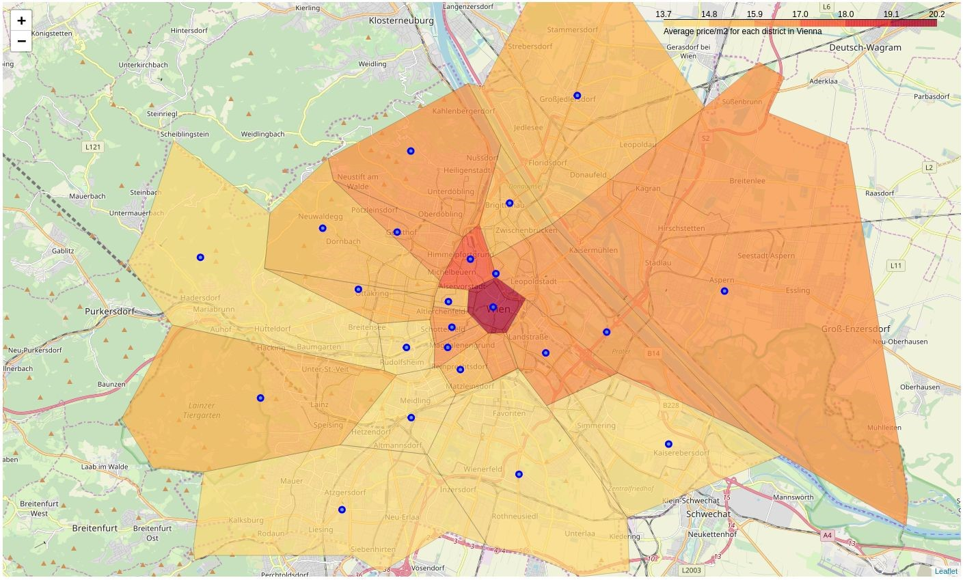

The average price/m2 for each district in Vienna

Results

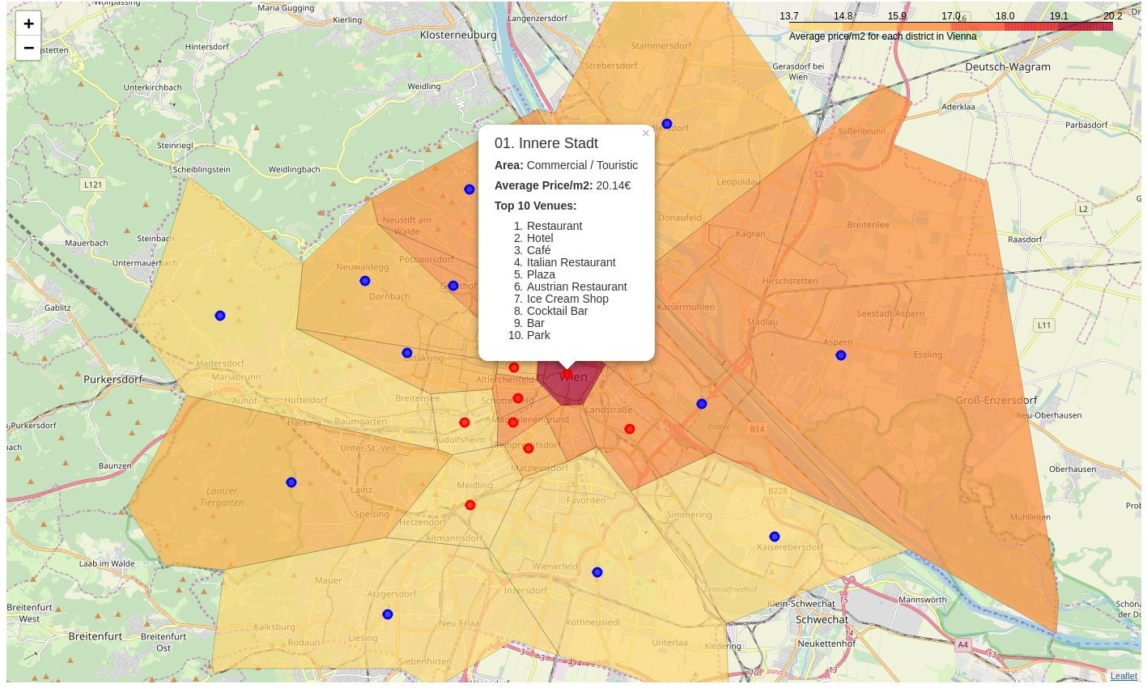

The average price/m2 for each district in Vienna with area types and top 10 venues per district

# Results

● With this map, one could determine for example that the 1st district is the most expensive district to live in, however by clustering we determined that there are several more similar districts where the price/m2 is significantly lower. Therefore, if someone wants to rent an apartment but cannot afford to live in the 1st district, they could look for apartments in the 12th or 15th district which is similar in venues but has much lower price for renting apartments.